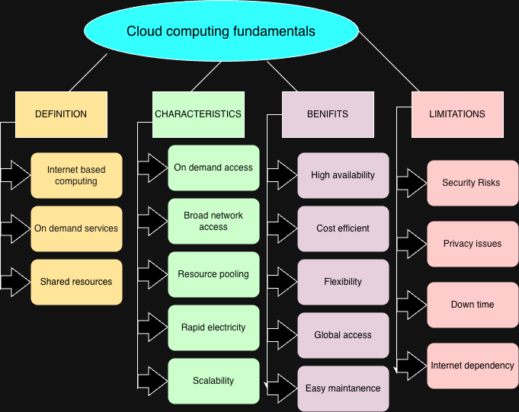

Box 1: Definition
⬇
- Internet-based Computing
- On-demand Services
- Shared Resources
- Remote Access
- Pay-as-you-go

Box 2: Characteristics
⬇
- On-demand Self Service
- Broad Network Access
- Resource Pooling
- Rapid Elasticity
- Measured Service

Box 3: Benefits
⬇
- Cost Efficiency
- High Availability
- Scalability
- Flexibility
- Easy Maintenance

Box 4: Limitations
⬇
- Security Risks
- Privacy Issues
- Internet Dependency
- Downtime
- Vendor Lock-in

CONCEPT MAP 2

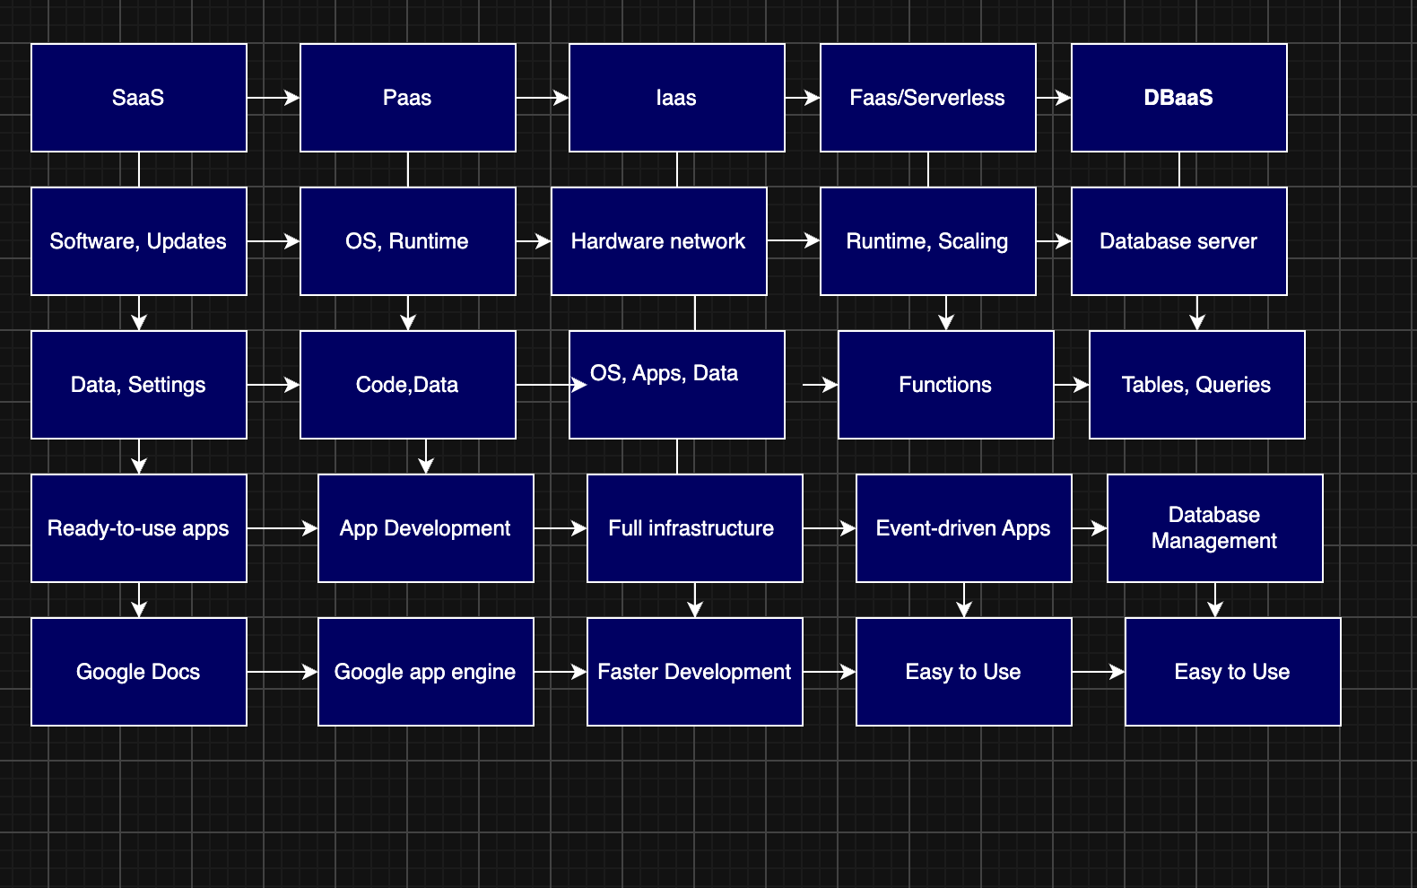

Box 1: IaaS
⬇
- Virtual Machines
- Storage
- Networking
- Provider → Hardware
- User → OS & Apps

Box 2: PaaS
⬇
- Runtime
- Middleware
- Development Tools
- Provider → Platform
- User → Code

Box 3: SaaS
⬇
- Ready-to-use Software
- Web Browser Access
- Provider → Application
- User → Data
- Subscription

Box 4: XaaS
⬇
- DBaaS
- Storage as a Service
- FaaS
- IDaaS
- Monitoring Service

CONCEPT MAP 3

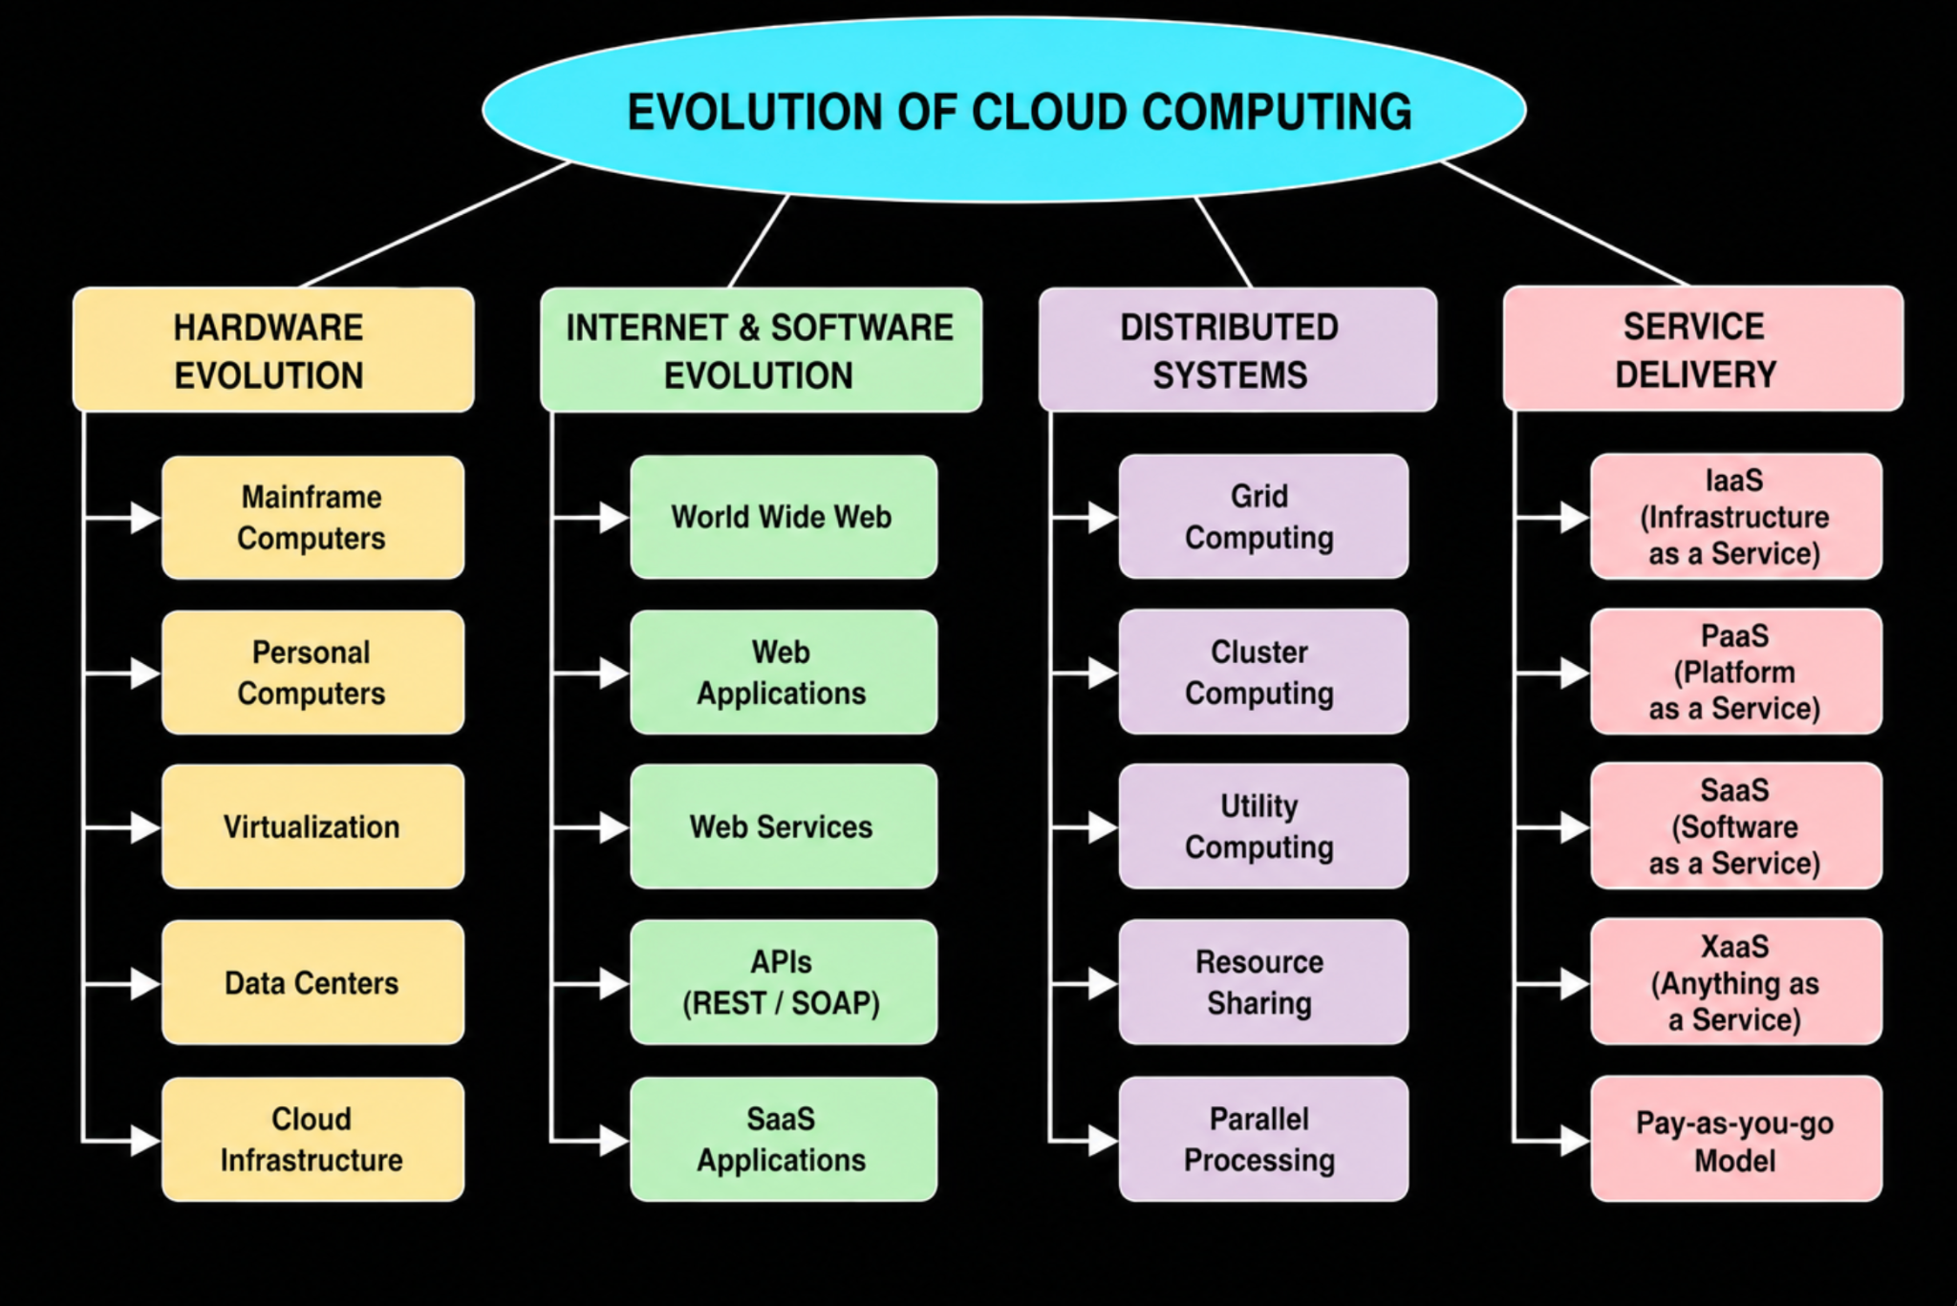
EVOLUTION OF CLOUD COMPUTING

Hardware Evolution
- Mainframe Computers
- Personal Computers
- Virtualization
- Data Centers
- Cloud Infrastructure

Internet & Software Evolution
- World Wide Web (WWW)
- Web Applications
- Web Services
- APIs (REST/SOAP)
- SaaS Applications

Distributed Systems
- Grid Computing
- Cluster Computing
- Utility Computing
- Resource Sharing
- Parallel Processing

Service Delivery
- IaaS (Infrastructure as a Service)
- PaaS (Platform as a Service)
- SaaS (Software as a Service)
- XaaS (Anything as a Service)
- Pay-as-you-go Model

CONCEPT MAP 4

Box 1: Virtualization
⬇
- Hypervisor
- Virtual Machine
- Resource Pooling
- Hardware Abstraction
- Isolation

Box 2: Web Services
⬇
- API
- SOAP
- REST
- XML/JSON
- Communication

Box 3: Cloud Deployment
⬇
- On-demand Access
- Scalability
- Elasticity
- High Availability
- Measured Service

Box 4: Cloud Scalability
⬇
- Load Balancing
- Auto Scaling
- Resource Pooling
- Fault Tolerance
- Performance

